***Android Based Text To Speech App (Urdu Version)***

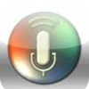

***User Help Guide for App***

**Contents**

**Table of Contents**

1. Introduction………………………………………………………………...1
2. Purpose of App……………………………………………………………..1
3. Compatibility checking……………………………………………………..1
4. Hardware……………………………………………………………………1
5. Software……………………………………………………………………..1
6. Installation…………………………………………………………………...1
7. How to install this app on Mobile…………………………………………….1
8. How to install this app on Desktop/Laptop. ……………………………….....2

V. Screen Shots……………………….………………………………………….5

Vi. How to use this App……………….………………………………………….7

Vii. App Error Handling…………………………………………………………..11

1. **Introduction**

This is basically an Android app which translates the English text into Urdu & then speak out its

Urdu translation.

1. **Purpose of App**

The Purpose of this app is that if someone wants the Urdu translation of any English text then by

Using this app user can easily achieve this goal. If someone does not know how to speak Urdu

Then this app will be helpful in this case also.

1. **Compatibility Checking**
2. **Hardware Compatibility**

This App is based on Android smartphone So, It will only run on android smartphones.

It is not compatible for those smartphones which does not contain android software.

1. **Software Compatibility**

This App will only be run on android version 4.4.2 (KitKat). Although it is compatible on other

Android version like jelly bean but it does not run properly on this version. So, for running this

App it is better to use android version KitKat.

1. **Installation**
2. **How to install this app on Mobile**

There are few steps in order to install this app on mobile.

***Step 1***

In this step Firstly you have to copy the .apk file from CD and then paste that on PC or Laptop.

**(1)**

***Step 2***

In second step you copy that .apk file from PC or Laptop and then attach your mobile using data cable with Laptop or PC and then paste that .apk file in SD card or Phone Storage of Mobile.

***Step 3***

In this step you go to your Mobile File Manager and then find that .apk file then after finding .apk file then tap that .apk. When you tap .apk file there are 2 options appear on screen. First is Install option and second is Cancel option If you want to install that app then tap the Install option. So after that it will be install in your mobile phone.

1. **How to install this app on Laptop/Desktop**

There are few steps in order to install this app on Laptop/Desktop.

***Step 1***

In this step firstly you need to install blue stack in your laptop/Desktop. You can install blue stack from CD or from the given link in the CD. In CD there is a folder named **setup** click on that folder& then you will see three files. You have to click on the file named ThinInstaller_native.exe. Make sure your internet is available on the laptop or desktop.

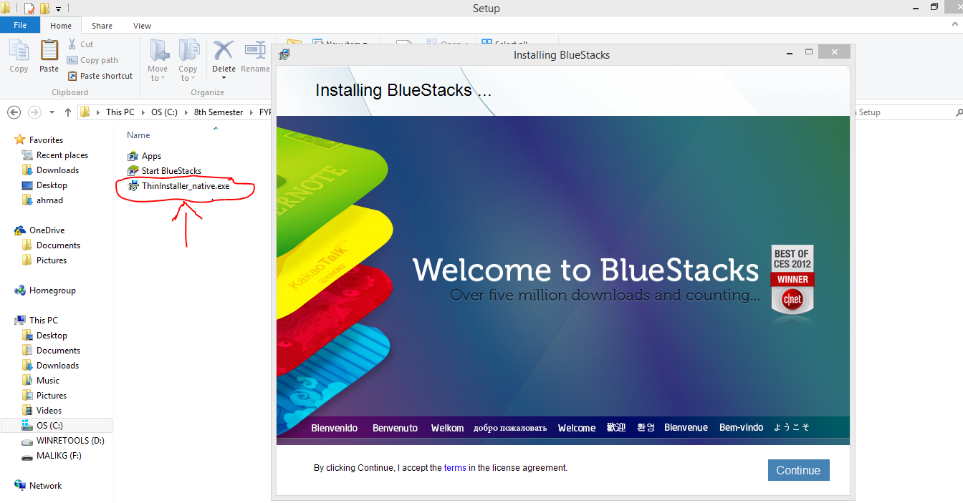

**(2)**

***Step 2***

In second step you need to open the blue stack.

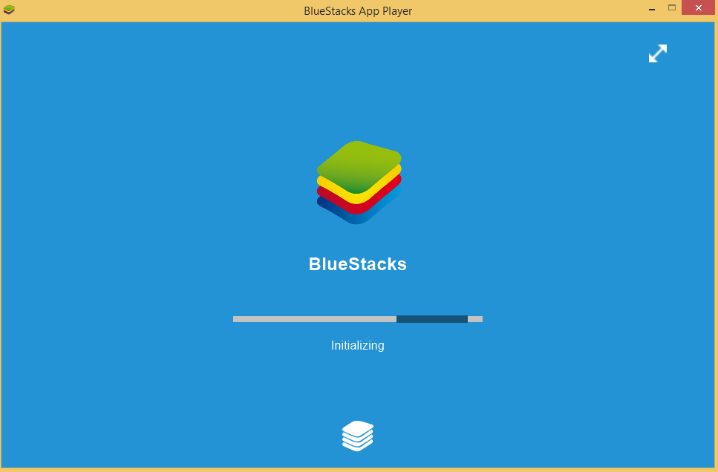

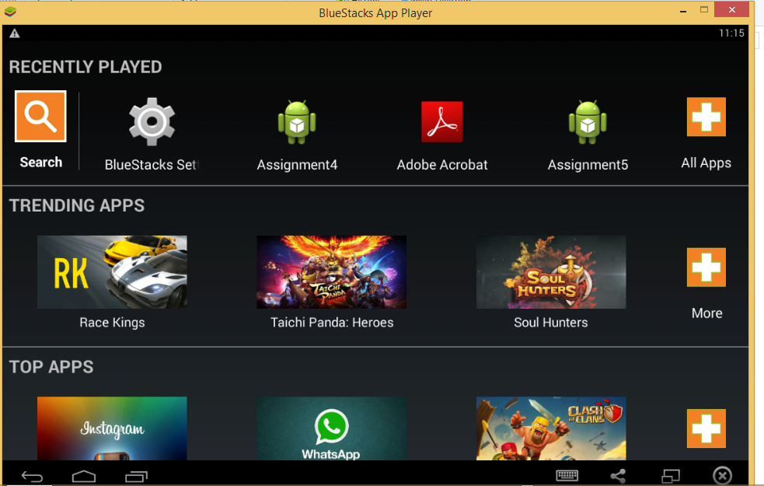

**(3)**

After opening the blue stack then double click on the Translator With Urdu Speech .apk file.

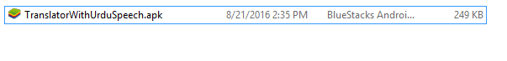

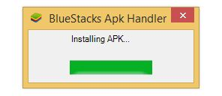

In this way your app will be installed on your laptop or on your Desktop.

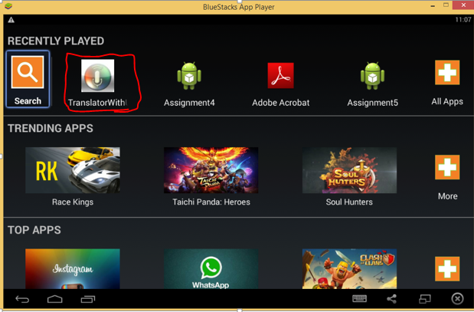

**(4)**

1. **Screenshots.**

**App Screen Shot1**

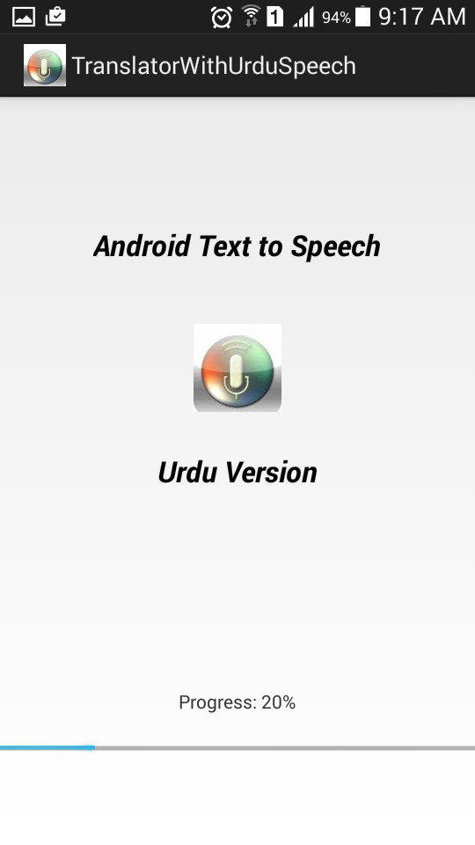

**(5)**

**App Screen Shot2**

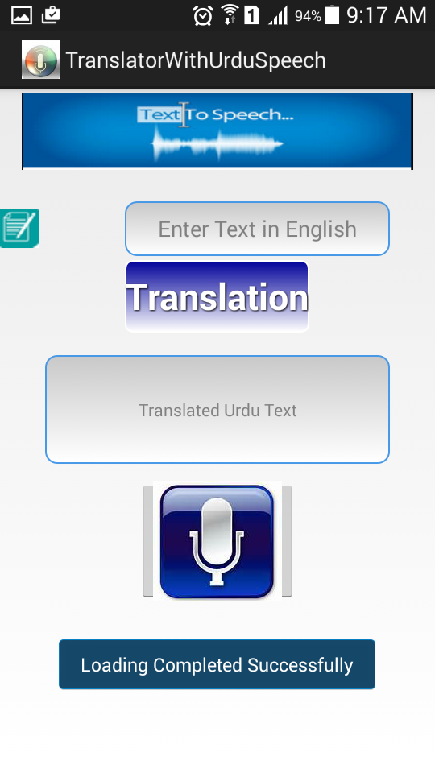

**(6)**

**Vi) How to use this app**

There are few steps in order to use this app.

***Step 1***

In this initial step a user firstly need to enable the Wi-Fi of mobile or laptop .After enabling the Wi-Fi user need to enter the English text in the input text box.

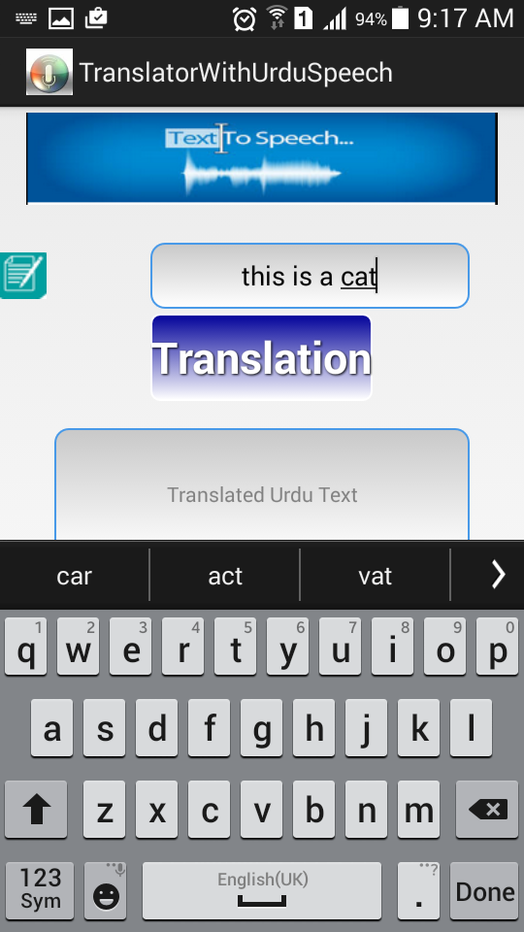

**(7)**

***Step 2***

After performing the initial step a user need to tap on the translation button.

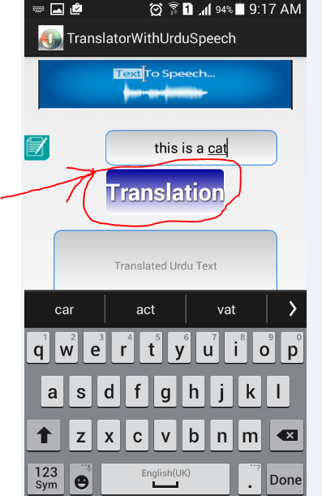

**(8)**

After tapping the translation button a user will see the Urdu translation of Entered English text in the translated text box.

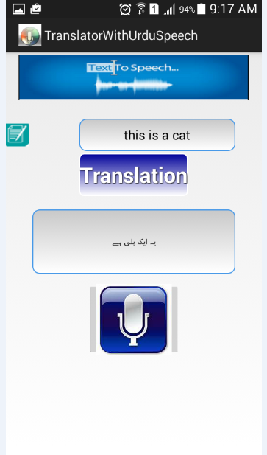

**(9)**

***Step 3***

After performing the second step a user need to tap on the speech button in order to listen the Urdu speech of the translated text.

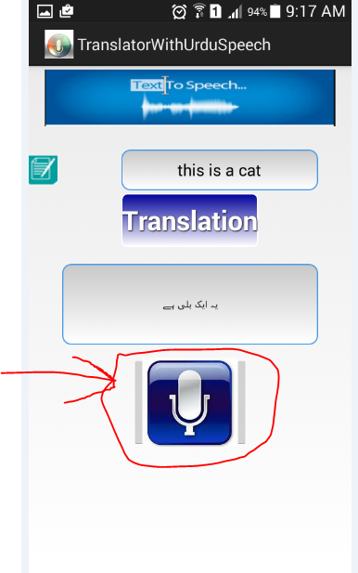

**(10)**

**Vii) App Error Handling**

There are few cases from which a user should aware of while using this app.

***Case1:***

If a user tap on the translation button directly without entering the English text in the input text box. Then an Empty Dialog message box appears.

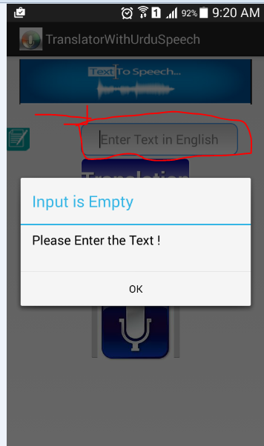

**(11)**

***Case2:***

If a user Input contains any sort of numbers or a user enter English text which contains any sort of numbers For instance 0-9.

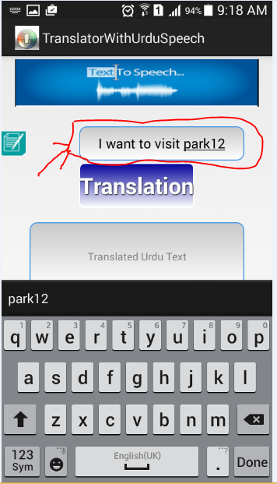

**(12)**

Then an Invalid Input Dialog message box appears & in result the app will resets the input text box.

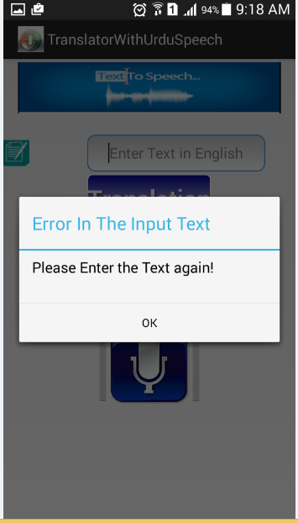

**(13)**

***Case3:***

If a user Input contains any sort of special symbols or a user enter English text which contains any sort of special symbols For instance < >#$.

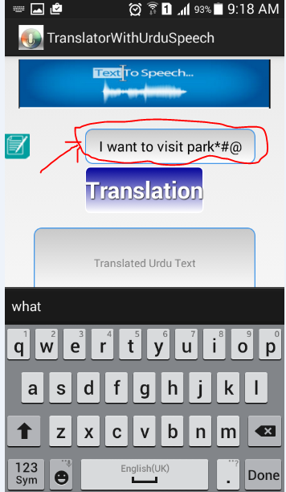

**(14)**

Then an Invalid Input Dialog message box appears & in result the app will resets the input text box.



**(15)**

***Case4:***

If a user tap on the Speech button directly without tapping on the translation button. Then Empty Translation Dialog message box appears & in result the app will resets the input text box.

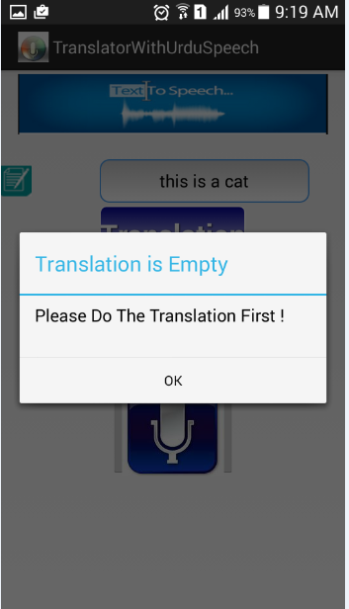

**(16)**